Performance Analysis
Yuanzhe Liu yuanz002 group:77

Test environment:
CPU: Intel i5-7200U @ 2.5GHz * 4
Harddisk: 33 MHz SSD
RAM: 1866 MHz LPDDR3

a. requests which cause HIT usually takes much less time than the ones causes MISS.
When the file is not in the cache, we need to read it from disk to cache, then send it to remote. While for the file already read in the cache, we can just send it to remote directly. Reading from disk is much slower because the disk has a much lower clock than RAM.

b. raw data:

workers | time start (s) | time end (s) | time cost (s)
1 | 22.9518 | 28.7799 | 5.8281
2 | 35.233 | 39.2487 | 4.0157
5 | 13.3893 | 16.5569 | 3.1676
10 | 46.9205 | 49.2172 | 2.2967
20 | 31.5455 | 34.233 | 2.6875
50 | 2.4049 | 5.3424 | 2.9375
75 | 38.5612 | 41.0143 | 2.4531
100 | 12.7486 | 15.0413 | 2.2927

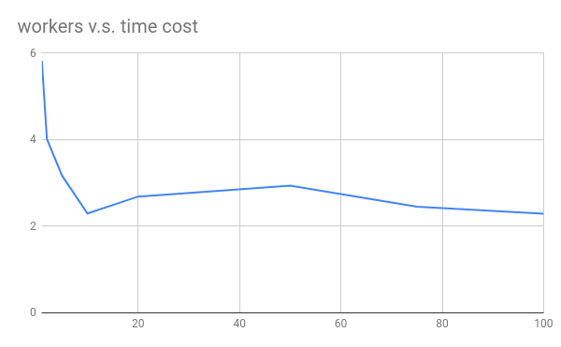
It is very obvious for the first few increments of workers, there is performance increase. But when workers are more than 5 there is not obvious trend. I think this is because I am testing on a quad-core cpu machine. Thread functions will utilize all 4 processors, but when there are more than 4 workers, workers begin to compete with each other for processors. So we can see a performance increase at the beginning but no more after that.

